Instructions pertaining to Interview for Part- Time Contractual Panel (Session : 2024-25)
GENERAL TERMS AND CONDITIONS:

- Minimum and Maximum age limit shall be 18 and 65 years respectively.
- No TA/DA will be paid for attending interview.
- This interview is only for preparing a panel of different posts to be engaged on purely part time contractual basis as and when required during the academic year 2024-25 and does not confer any right to get regular appointment in KVS. The contractual teachers would be engaged till such time the regular teacher joins or the end of the academic session, whichever is earlier. However, their services can be terminated earlier if their performance is not satisfactory.
- Educational qualification remuneration and working hours would be as per KVS norms.
- Registration is essential to appear in the interview and it will be from 08:00 AM to 09:00 AM only in the school. Interview process would start from 09:30 AM onward on stipulated date.
- Separate applications will be accepted for different post.
- Proficiency in teaching in Hindi and English medium is required. Computer Knowledge is desirable. Candidate would appear in the interview with duly filled registration form, self-attested photocopies of the documents with its original for verification.
- Candidates must be capable of teaching in hybrid mode using the platforms provided by KVS, like Google Classroom, Google Meet, Classroom live, etc.
- Original documents should be brought for verification at the time of interview.

- DRESS CODE- Every teacher shall be clean and trim. She/he shall not be casual and informal, while on duty. Her/his dress shall be neat and dignified. She/he shall on no account be dressed so as to become an object of excitement or ridicule or pity at the hands of students and colleagues.

11. Contractual teachers/ staffs may be appointed on purely contractual basis in Vidyalaya’s of cluster selected by him/ her.

JOB DESCRIPTION OF TEACHERS (PGT, TGT, PRT)

Contractual teachers will perform all the duties similar to a regular teacher. Their job description includes-
- Teaching of their subject as per KVS and CBSE standards.
- Timely correction of class and home assignments, test-papers, projects, etc.
- Setting of question papers for various tests and exams, when asked by the examination department.
- Preparation of lesson plans and maintain academic record of the students
- Preparing the students for co-curricular activities, house activities, various cultural competitions, etc.
- If required, escorting the students for activities outside Vidyalaya.
- Completion of any other work assigned by Vidyalaya.

JOB DESCRIPTION OF DOCTORS AND NURSES:
  - The doctors are expected to give two hours of service on all working days.
  - Services of nurses will be required for half hour before and half hour after Vidyalaya hours. Total Working hours will be 7 hours.
  - Doctor and nurse should be available on all working days for the students except during the vacations/ breaks or when the school is closed on other account.
  - Doctor and nurse shall do the medical check-up of the students twice a year.
  - They shall be available for all emergencies in school.
  - They will carry out awareness programme in assembly and classrooms on issues related to health like obesity, malnutrition, diet, communicable diseases, adolescent related problems, health and hygiene, etc.

JOB DESCRIPTION OF COUNSELLORS:
- Counsellors will address the mental health of the students and provide them guidance as and when required.
- They will carry out awareness programmes to enhance life skills and values.
- They will address the behaviour pattern of the students and contribute to school discipline.
- Their nature of work involves low achieving, under achieving, and high achieving students, besides dealing with topics like examination fear, stress management, study skills and techniques, etc.
- They will provide career guidance and help the students in assessing their interests and aptitudes.

JOB DESCRIPTION OF COACH, COMPUTER INSTRUCTOR

The instructors and coaches will perform all the duties similar to regular teachers in these subjects. Their job description includes-
  - Developing the ability of creative expression/ teaching techniques, tactics and relevant skills of sports activities in students/ to provide theoretical and applied instructions in computer functionality
  - Developing lessons plans related to their subjects
  - Assisting the regular teachers in developing the proficiencies related to their subject
  - Preparing the students for various school level, regional level and national level competitions

JOB DESCRIPTION OF SPECIAL EDUCATOR:

- Special educator will work with students who have learning, mental, emotional or physical disabilities.
- They will adapt general education lessons and teach various subjects to students with disabilities.
- They will teach basic skills to such students that help them in performing their day-today activities smoothly.
- They will collaborate with parents and school staff to track students’ progress.

REQUIRED QUALIFICATIONS:-

- For PGTs :-

Essential Qualification:

  - Two years’ Integrated Post Graduate M.Sc Course of Regional College of Education of NCERT in the concerned subject;

OR

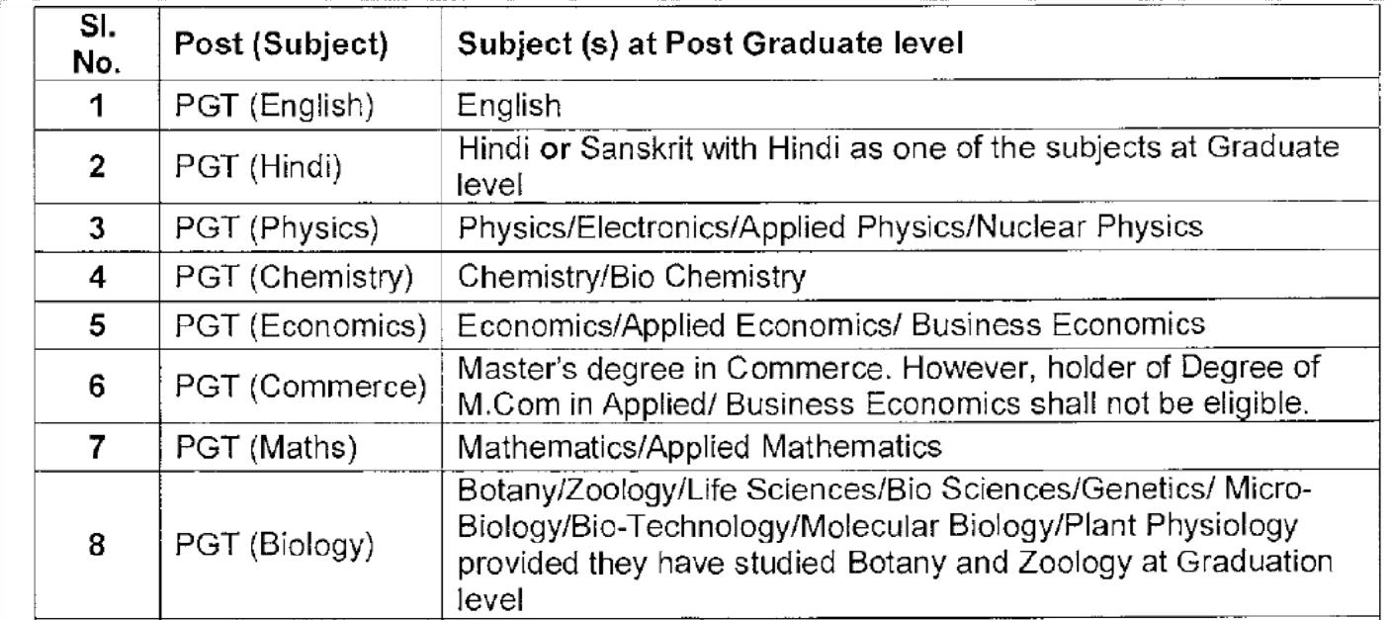
Master Degree from a recognized University with at least 50%marks in aggregate in the following subjects:

  - B.Ed. or equivalent degree from recognized university
  - Proficiency in teaching in Hindi and English media.

Desirable Qualification :
- For PGT (Computer Science):-

Essential Qualification :

  - At-least 50 % marks in aggregate in any of the following;
B.E or B. Tech. (Computer Science/IT) from a recognized University or equivalent Degree or Diploma from an institution/university recognized by the Govt. of India.

OR
B.E or B. Tech. (any stream) and Post Graduate Diploma in Computers from recognized University.

OR
M.Sc (Computer Science)/ MCA or Equivalent from a recognized
University. OR
B.Sc (Computer Science) / BCA or Equivalent and Post Graduate degree in subject from a recognized University.

OR
Post Graduate Diploma in Computer and Post Graduate degree in any subject from recognized University.

OR
‘B’ Level from DOEACC and Post Graduate degree in any
subject. OR
‘C’ Level from ‘DOEACC’ Ministry of Information and Communication Technology and Graduation.

  - Proficiency in teaching in Hindi and English.

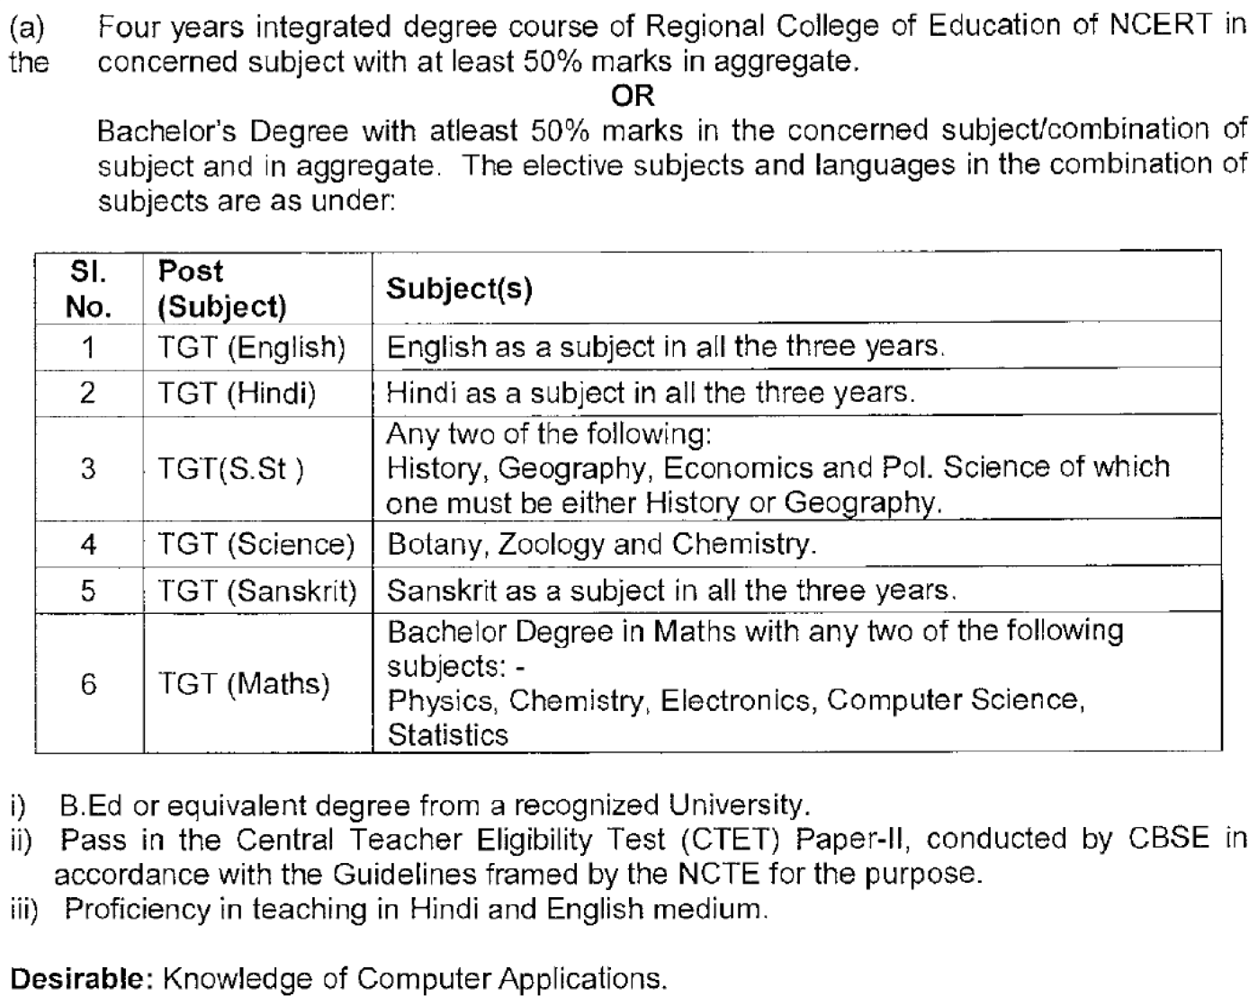
For TGTs:- Essential Qualification:
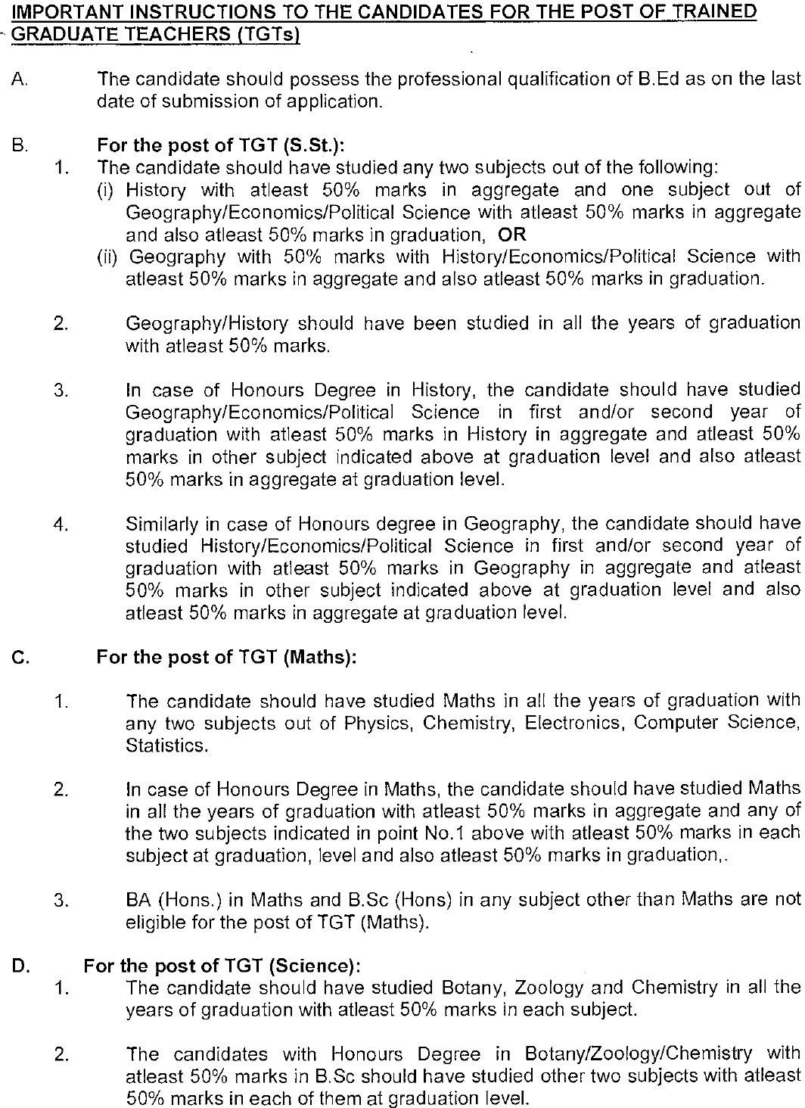

- For PRT:-

Essential :
a)
Senior Secondary (or its equivalent ) with at least 50% marks and 2-year Diploma in Elementary Education (by whatever name known) OR Senior Secondary (or its equivalent) with at least 50% marks and 4-year Bachelor of Elementary Education (B.El.Ed.)

OR
Senior Secondary (or its equivalent ) with at least 50% marks and 2-year Diploma in Education (Special Education )

- Qualified in the Central Teacher Eligibility Test (CTET) Paper I conducted by the Govt. of India.
- Proficiency to teach through Hindi & English media. Desirable :
Knowledge of Computer Applications.
- For Computer Instructor:- Essential :
  - At-least 50 % marks in aggregate in any of the following;
B.E or B. Tech. (Computer Science/IT)/BCA/MCA/M.Sc. (Computer Science)/ M.Sc. (Electronics with Computer Science component)/ M.Sc. (IT)/B.Sc. (Computer Science ) from a recognized University.

OR
Bachelor’s/ Master degree in any Science subject/ Mathematics from recognized University with Post Graduate Diploma in Computer Application from government recognized University/ institute.

OR
Post Graduate degree in any subject with Post Graduate Diploma in Computer Application from government recognized University/ institute / ‘A’ Level from ‘DOEACC’
a. Proficiency in teaching in Hindi and English media. Desirable :
Knowledge of Tux Paint, Libre Office, Scratch, Python Turtle, Python
- For Special Educators :-
- Elementary (primary and upper primary):
  - XII passed and two year D.Ed. Special education in any of the category of disability. OR
  - XII passed and one year diploma in special education (DSE) in any of the category disability.

OR
  - Diploma in community based rehabilitation (DCRB) with six months certificate course in education of children with special needs.

OR
  - Post graduate diploma in community based rehabilitation with six months certificate course in education of children with special needs.

OR
  - Diploma in Multi rehabilitation worker with six months certificate course in education of children with special needs

OR
  - Junior diploma in teaching the deaf

OR
  - Primary level teacher teaching course in visual impairment.

OR
  - Diploma in vocational rehabilitation mental retardation (DVR-MR)/ diploma in vocational training and employment mental retardation (DVTE-MR) with six months certificate course in education of children with special needs.

OR
  - Diploma in hearing language and speech with six months certificate course in education of children with special needs.

OR
  - XII passed with RCI recognized qualification for minimum one year duration and six months with special needs.

OR
Any other equivalent qualification approved by RCI

(b) Secondary and senior Secondary:
- Graduate with B.Ed. (special education).

OR
- B.Ed. (General) with one year diploma in special education.

OR
- B.Ed. (General) with two-year diploma in special education.

OR
- B.Ed. (General) with Post Graduate Professional Diploma in Special Education (PGPD).

OR
- B.Ed. Special Education and Post Graduate Professional Certificate in Special Education (PGPC).

OR
- PG Diploma in Special Education (Mental Retardation)

OR
- PG Diploma in Special Education (Multiple Disabilities: Physical And Neurological).

OR
- PG Diploma in Special Education (Locornotor Impairment And Cerebral Palsy). OR
- Secondary Level Teacher Training Course In Visual Impairment.

OR
- Senior Diploma in Teaching the Deaf.

OR
- BA/ B.Ed. in Visual Impairment.

OR
Any other equivalent qualification approved by RCI

- For other Posts:-

SL. NO | Name of the post | Qualification
1. | Sports Coach | Diploma from NSNIS/B.P.Ed./Graduation in Physical Education/ represented at National level /Inter university level. Any equivalent coaching experience of recognized institution.
2. | Yoga Teacher | 1) Graduation in any subject or equivalent from a recognized  University. 2) One year Training in Yoga from a recognized Instt.
3. | Counsellor | Essential:  B.A. / B.Sc. (Psychology) with Certificate of Diploma in Counselling from a recognized college or University.  Desirable :  Minimum of one year Experience in providing career educational counseling to students at schools.  OR  Working knowledge and experience in Placement bureaus.  OR  Registration with rehabilitation council of India as Vocational Counselor.
4. | Doctor | Minimum MBBS and registered with MCI
5. | Nurse | Three year Diploma in General Nursing and Midwifery or B.Sc. in nursing from recognized institution.

