Star Students secured 100 marks in Subjects (2022-23)

Name | Class/Sec | Subject | Marks
MEHAK | 10 B | A.I | 100

Toppers 2022-23

Toppers | Name | Photos | Percentage
XII Science | VAISHNAVI YADAV | 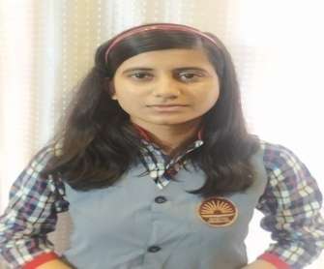 | 85.8
XII Commerce | GURKIRAT KAUR | 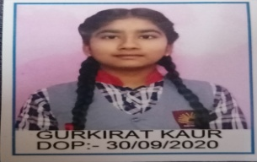 | 93.4
XI (Comm.) | PIYUSH GOYAL | 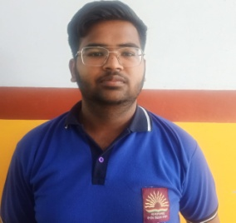 | 83.8
XI (Sci.) | MINAKSHI | 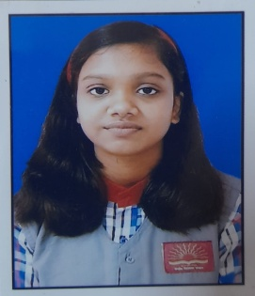 | 84
X overall | MAHAK YADAV | 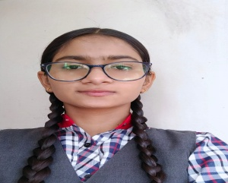 | 95.6
IX | PRIYANSHU | 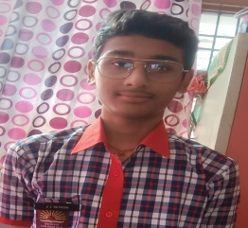 | 90.8

Star Students secured 95 to 97 marks in subjects

S.NO. | Name | Class/Sec | Subject | Marks
1 | Akshat | X-A | ENG | 96
2 | Sudhanshu | X-A | ENG | 96
3 | Ananya | X-A | ENG | 95
4 | Samridhi | X-A | ENG | 95
5 | Chirag | X-C | ENG | 95
6 | Ananya | X-A | Hindi | 95
7 | Deepak | X-B | Hindi | 95
8 | Diksha | X-B | Hindi | 95
9 | Shristi | X-C | Hindi | 95
10 | Nikhil | X-A | Maths | 95
11 | Mahak | X-B | Maths | 95
12 | Javik | X-A | Science | 95
13 | Mehak | X-B | Science | 95
14 | Chirag | X-C | Science | 95
15 | Abhi | X-A | S.ST | 96
16 | Aarnat | X-A | S.ST | 95
17 | Simar | X-B | S.ST | 96
18 | Mahak | X-B | S.ST | 97
19 | Mehak | X-B | S.ST | 96
20 | Mahak | X-B | A.I. | 100
21 | Rajni | X-C | A.I. | 98
22 | Javik | X-A | A.I. | 97
23 | Samriddhi | X-A | A.I. | 97
24 | Shubham | X-B | A.I. | 97
25 | Simar | X-B | A.I. | 96
26 | Deepak | X-B | A.I. | 96
27 | Yatin | X-B | A.I. | 96
28 | Chirag | X-C | A.I. | 96
29 | Ananya | X-A | A.I. | 95
30 | Sudhanshu | X-A | A.I. | 95
31 | Shristi | X-C | A.I. | 95
32 | Vaishnavi | XII-A | Eng | 96
33 | Devender Kumar | XII-B | Accountancy | 95
34 | Gurpreet kaur | XII-B | Accountancy | 95
35 | Gurkirat Kaur | XII-B | Accountancy | 95
36 | Vaibhav Aggarwal | XII-B | Accountancy | 95
37 | Sushant | XII-A | Physicsl Education | 95

51 ^{st} KVS REGIONAL SPORTS MEET 2022-23
TOTAL PARTICIPANTS ARE 90 & 65 ARE POSITION HOLDER
EVENT : JUDO
Position | BOYS | GIRLS
GOLD | 7 | 6
SILVER | 4 | 2
BRONZE | 5 | 6
TOTAL | 16 | 14
EVENT : ATHLETICS
S.NO. | BOYS | GIRLS
GOLD | 2 | 1
SILVER | 2 | 1
BRONZE | 2 | 3
TOTAL | 6 | 5
EVENT : BOXING
S.NO. | BOYS | GIRLS
GOLD | 2 | 3
SILVER | 4 | 3
BRONZE | 2 | 1
TOTAL | 8 | 7
EVENT :TAEKWANDO
S.NO. | BOYS | GIRLS
GOLD | 1 | 1
TOTAL | 1 | 1
EVENT :YOGA
S.NO. | BOYS | GIRLS
BRONZE | 1 | 0
TOTAL | 1 | 0

51 ^{st} KVS, NATIONAL SPORTS MEET 2022-23
 | 8 POSITION HOLDER
S.NO. | EVENTS | STUDENT NAME | POSITION | CLASS
1 | YOGA | VANSH | 2nd | VII A
2 | JUDO | AARUSHI DEVI | 3rd | VII A
3 | BOXING | YASH | 3rd | VII A
4 | BOXING | KRITIKA KAMBOJ | 3rd | VII A
5 | BOXING | SURBHI | 4th | VIII
6 | JUDO | ANSHIKA | 5th | VIII
7 | BOXING | KANIKA | 5th | VI
8 | ATHLETE | ISHANI SINGH | 5th | IX B

